Answers are in blue.

# For Exercises 1–31, mark the answers true and false as follows:



**Computer Science Illuminated, Seventh Edition**

Nell Dale, PhD; John Lewis, PhD

**CHAPTER 12**

EXERCISES AND ANSWERS

1. **True**
2. **False**
   1. A cell in a spreadsheet can contain only raw data. B
   2. The values in a spreadsheet can be formatted in a variety of ways.

## A

* 1. A spreadsheet should be set up so that changes to the data are automatically reflected in any cells affected by that data. A
  2. A spreadsheet function is a program that the user writes to compute a value.

B (they are built into the software)

* 1. A range of cells can be specified that go horizontally or ver- tically, but not both.

## B

* 1. A circular reference in a spreadsheet is a powerful and useful situation.

## B

* 1. A spreadsheet is useful for performing what-if analysis. A
  2. What-if analysis can only affect one value at a time in a spreadsheet.

## B

* 1. A database engine is software that supports access to the database contents.

## A

* 1. The physical database represents the logical structure of the data in the database.

## B

* 1. A query is a request to a database for information. A
  2. The results of a query can be structured in many ways. A
  3. The hierarchical model is the most popular database man- agement model today.

## B

* 1. A database table is a collection of records, and a record is a collection of fields.

## A

* 1. The values in the key fields of a table uniquely identify a record among all other records in the table.

## A

* 1. A database engine often interacts with a particular language for accessing and modifying the database.

## A

* 1. An entity-relationship (ER) diagram represents primary data- base elements in a graphical form.

## A

* 1. The cardinality of a relationship puts restrictions on the num- ber of relationships that can exist at one time.

## A

* 1. E-commerce is the process of keeping financial records, such as accounts payable, online.

## B

* 1. The dot-com collapse promoted electronic commerce. A

# For Exercises 21–25, match the solution to the question using the spreadsheet shown.

* + 1. **Dynamic**
    2. **Function**
    3. **Circular**
    4. **Range**
    5. **Schema**
    6. **Field**
  1. A spreadsheet is in that it responds to changes in the data by immediately updating all affected values.

## A

* 1. A spreadsheet formula may operate on a of cells, such as C4..C18.

## D

* 1. The database is the specification of the logical structure of the data in the database.

## E

* 1. A reference occurs when the result of one formula is ultimately based on another, and vice versa.

## C

* 1. A contains a single data value. F

**Exercises 26–38 are problems or short answer questions.** Use the following spreadsheet that contains student grades for Exercises 26–34.

|  |  |  |  |  |  |  |  |
| --- | --- | --- | --- | --- | --- | --- | --- |
|  | A | B | C | D | E | F | G |
| 1 |  |  |  |  | Grades |  |  |
| 2 |  |  |  | Exam 1 | Exam 2 | Exam 3 | Average |
| 3 |  |  |  |  |  |  |  |
| 4 |  |  | Bill | 89 | 33 | 80 | 67.3333 |
| 5 |  |  | Bob | 90 | 50 | 75 | 71.6666 |
| 6 |  |  | Chris | 66 | 60 | 70 | 65.3333 |
| 7 |  | Students | Jim | 50 | 75 | 77 | 67.3333 |
| 8 |  |  | Judy | 80 | 80 | 80 | 80 |
| 9 |  |  | June | 83 | 84 | 85 | 84 |
| 10 |  |  | Mari | 87 | 89 | 90 | 88.6666 |
| 11 |  |  | Mary | 99 | 98 | 90 | 95.6666 |
| 12 |  |  | Phil | 89 | 90 | 85 | 88 |
| 13 |  |  | Sarah | 75 | 90 | 85 | 83.3333 |
| 14 |  |  | Susy | 85 | 90 | 95 | 90 |
| 15 |  | Total |  | 893 | 839 | 912 | 881.333 |
| 16 |  | Average |  | 81.1818 | 76.2727 | 82.9090 | 80.1212 |

* 1. Specify the grades for Exam 2. E4..E14
  2. Specify the average for Exam 1. D15
  3. Specify the average for Sarah. G13
  4. Specify the third exam grade for Mari. F10
  5. Specify the exam grades for Susy. D14..F14
  6. What formula is stored in F15? SUM(F4..F14)
  7. D16 contains the formula D15/COUNT(D4..D14). What is another formula that would yield the same value? AVERAGE(D4..D14)
  8. Which formula is stored in E13?

There isn’t a formula stored there; it is a single value.

* 1. What values in what cells would change if Phil’s exam 2 score was corrected to 87?

## F12, F15, F16, G12, G15

* 1. What is a spreadsheet circular reference? Why is it a problem? A circular reference is one in which two or more formulas depend upon each other. For example, F5 may use D4 in its calculation, and D4 may use F5 in its calculation. A circular reference may be direct as in the F5, D4 example, or indirect, involving many different formulas. The problem is that the calculation cannot be made because of the interdependence of the references.
  2. Give a specific example of an indirect circular reference simi- lar to the one shown in Figure 12.5.

B1  SUM(A1..A5) * C2 C2  SUM(B5..B12)

B8  G1  D2

D2  G3 * B1

B1 depends on C2; C2 depends on B8; B8 depends on D2; and D2 depends on B1.

* 1. What is what-if analysis?

The values representing assumptions in a spreadsheet can be changed and the effects on related data can be observed. This varying of values and the observation of the results rep- resent what-if analysis—that is, you can ask what happens if you change certain values and see the results.

* 1. Name some what-if analysis questions that you might ask if you were using a spreadsheet to plan and track some stock purchases. Explain how you might set up a spreadsheet to help answer those questions.

We are considering buying stock in four Fortune Five Hun- dred companies.

What would my gain be if all four of the stocks gained 6% over a year?

What would my gain be if two gained 6% over a year, but the other two lost 2%?

What would my loss be if all four lost 2%?

All of these percentages could be varied and the results examined.

The spreadsheet could be set up with the stock names in B2.. B5, the initial prices in C2..C5, the calculated prices based on percentage gains or losses per stock in D2..D5. C6 could contain the formula for summing C2..C5. D6 could contain the formula for summing D2..D5. E6 could contain the for- mula for subtracting C6 from D6 to calculate the gain or loss.

**For questions 39 through 42, use the paper spread- sheet form supplied on the textbook’s website or use an actual spreadsheet application program to design the spreadsheets. Your instructor may provide more specific instructions regarding these questions.**

These are activities for which there are no specific answers.

* 1. Design a spreadsheet to track the statistics of your favorite major league baseball team. Include data regarding runs, hits, errors, and runs-batted-in (RBIs). Compute appropriate statistics for individual players and the team as a whole.
  2. Design a spreadsheet to maintain a grade sheet for a set of students. Include tests and projects, given various weights to each in the calculation of the final grade for each student. Compute the average grade per test and project for the whole class.
  3. Assume you are going on a business trip. Design a spread- sheet to keep track of your expenses and create a summary of your totals. Include various aspects of travel such as car mileage, flight costs, hotel costs, and miscellaneous (such as taxis and tips).
  4. Design a spreadsheet to estimate and then keep track of a particular project’s activities. List the activities, the estimated and actual dates for those activities, and schedule slippage or gain. Add other data as appropriate for your project.
  5. Compare a database with a database management system. A database is a structured set of data. A database manage- ment system is a software system made up of the database, a database engine (for manipulating the database), and a data- base schema that provides the logical view of the database.
  6. What is a database schema?

A database schema is the specification of the logical struc- ture of a database.

* 1. Describe the general organization of a relational database. A relational database is organized around the concept of a table. Both data and relationships are represented in tables.
  2. What is a field (attribute) in a database?

A field is a single value in a database record. A field rep- resents one aspect or attribute of the item in a database.

* 1. Which other fields (attributes) might we include in the data- base table of Figure 12.8?

There are four fields in the table in Figure 12.8 that describe a movie: MovieID, Title, Genre, and Rating. Additional items might be Director, MaleLead, FemaleLead, Producer, and Date.

* 1. Which other fields (attributes) might we include in the data- base table of Figure 12.9?

There are four fields in the table in Figure 12.9 that describe a customer: CustomerID, Name, Address, and CreditCardNumber. Additional items might be PhoneNumber, HighestRatingAccept- able, and MaxMovies.

* 1. What is a key in a relational database table?

In a relational database, every record in a table must be uniquely identified. The field or combination of fields that are used to uniquely identify records in a table is called the *key field*.

* 1. Specify the schema for the database table of Figure 12.9.

Customer(CustomerId, Name, Address, CreditCardNumber)

* 1. How are relationships represented in a relational database? In a table, of course! A table is created that represents the relationship. Usually, the keys of both items in the relation- ships are represented as fields in the relationship table, along with appropriate information about the relationship.
  2. Define an SQL query that returns all attributes of all records in the Customer table.

select * from Customer

* 1. Define an SQL query that returns the movie MovieId and title of all movies that have an R rating.

select MovieId, Title from Movie where Rating = ‘R’

* 1. Define an SQL query that returns the address of every cus- tomer in the Customer table that lives on Lois Lane.

select Address from Customer where Address like ‘%Lois Lane%’

* 1. Define an SQL statement that inserts the movie *Armageddon*

into the Movie table.

insert into Movie values(1433, Armageddon, action sci-fi, R)

* 1. Define an SQL statement that changes the address of Amy Stevens in the Customer table.

update Customer set Address = ‘333 Silver Way’ where Name = ‘Amy Stevens’

* 1. Define an SQL statement that deletes the customer with a

CustomerId of 103.

delete from Customer where CustomerId = 103

* 1. What is an ER diagram?

An ER diagram is a graphical representation of an entity-re- lationship model, which is a technique for design relational databases.

* 1. How are entities and relationships represented in an ER diagram?

In an ER diagram, tables are represented by rectangles and diamonds represents relationships.

* 1. How are attributes represented in an ER diagram? Attributes are represented in ovals with lines connecting them to the entity they describe.
  2. What are cardinality constraints and how are they shown in ER diagrams?

Cardinality constraints are the number of relationships that can exist between entities in an ER diagram. They are repre- sented by the number 1 and the letter M (for many). These values are written on the line connecting the table and the relationship.

* 1. What are the three general cardinality constraints? One to one, one to many, and many to many.
  2. Design a database that stores data about the books in a library, the students that use them, and the ability to check out books for a period of time. Create an ER diagram and sample tables.

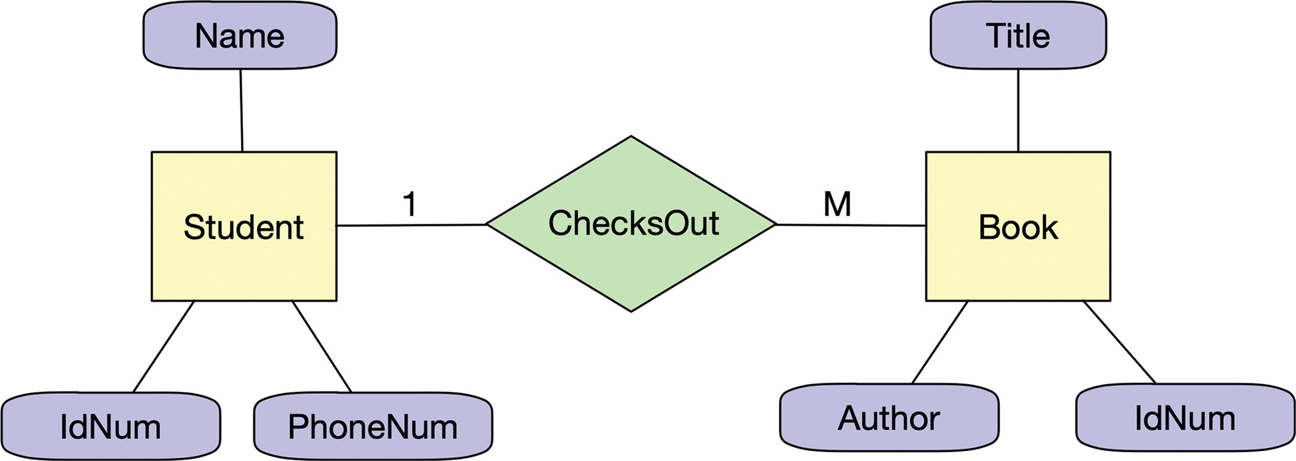

Students

|  |  |  |
| --- | --- | --- |
| **IdNum** | **Name** | **PhonNo** |
| 223456789 | Sally Silent | 232-4432 |
| 432543654 | Lottie Loud | 343-3321 |
| 898978675 | Maud Middle | 454-3452 |

Books

|  |  |  |
| --- | --- | --- |
| IdNum | Author | **Title** |
| 443233 | Brown | Fly Fishing in the Sahara |
| 567622 | Smith | Dust Storms in the Amazon Basin |
| 657687 | Anderson | Skating on Thin Ice |

ChecksOut

|  |  |  |
| --- | --- | --- |
| **IdNum** | **IdNum** | **DateDue** |
| 443233 | Brown | 10/23/2004 |
| 567622 | Smith | 10/30/2004 |
| 657687 | Anderson | 11/1/2004 |

* 1. Design a database that stores data about the courses taught at a university, the professors that teach those courses, and the students that take those courses. Create an ER diagram and sample tables.

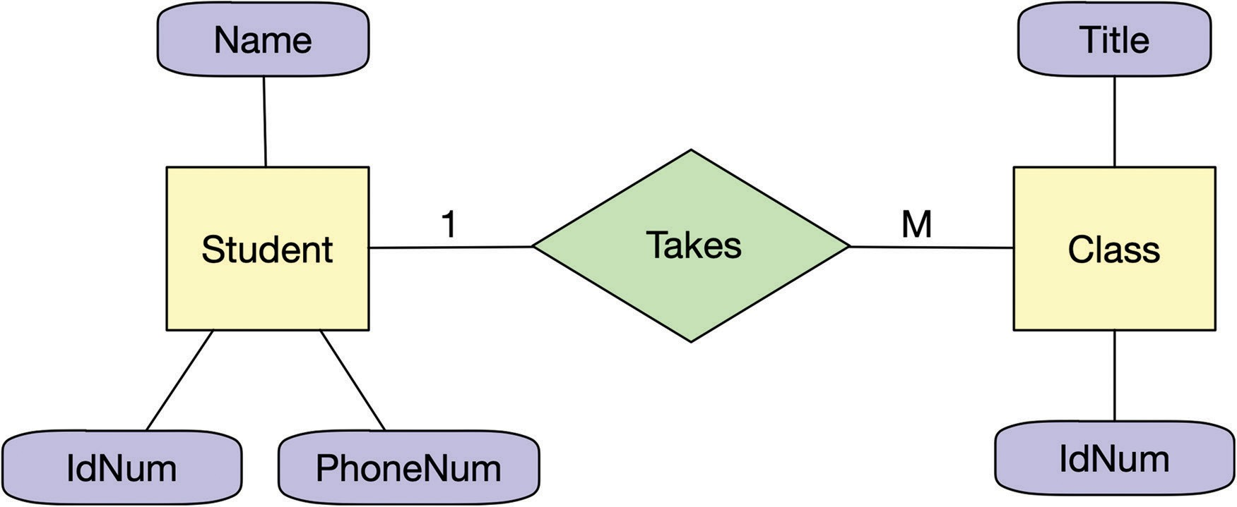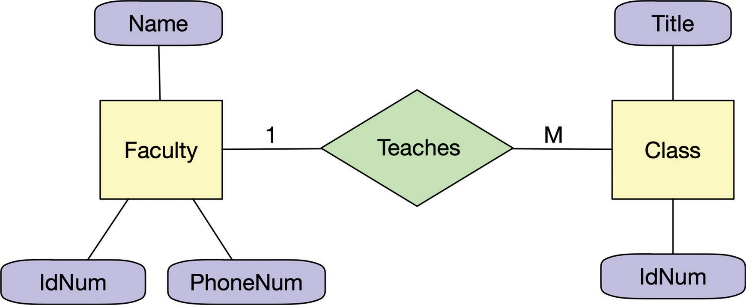

Students

|  |  |  |
| --- | --- | --- |
| **IdNum** | **Name** | **PhonNo** |
| 223456789 | Sally Silent | 232-4432 |
| 432543654 | Lottie Loud | 343-3321 |
| 898978675 | Maud Middle | 454-3452 |

Faculty

|  |  |  |
| --- | --- | --- |
| **IdNum** | **Name** | **PhonNo** |
| 344567777 | Abby Absent | 632-4432 |
| 222222222 | Steven Stern | 373-3321 |
| 434343434 | Mary Modern | 453-3452 |

Courses

|  |  |
| --- | --- |
| **IdNum** | **Title** |
| CS304 | Introduction to CS |
| CS328 | Abstract Data Types |
| CS375 | Compiler Design |

* 1. What were some of the web-based technologies that allowed e-commerce to become viable?

E-commerce became viable through the evolution of online storefronts (such as Amazon), electronic shopping carts, and online payment systems (such as PayPal).

* 1. What is big data? How does it relate to spreadsheets and databases?

*Big data* is the term used to describe the management and analysis of massive and complex data sets that cannot be handled by traditional technologies such as spreadsheets and databases.

* 1. Name three challenges in big data analysis.

The challenges include (1) the size and complexity of the data, (2) the amount of memory required, (3) the ability to organize and analyze the information meaningfully, and

(4) protecting that data.